**3. ReactJS-HOL**

Create a React app for Student Management Portal named scorecalculatorapp and create a function component named “CalculateScore” which will accept Name, School, Total and goal in order to calculate the average score of a student and display the same.

**Steps:**

* Create a React project named “scorecalculatorapp”

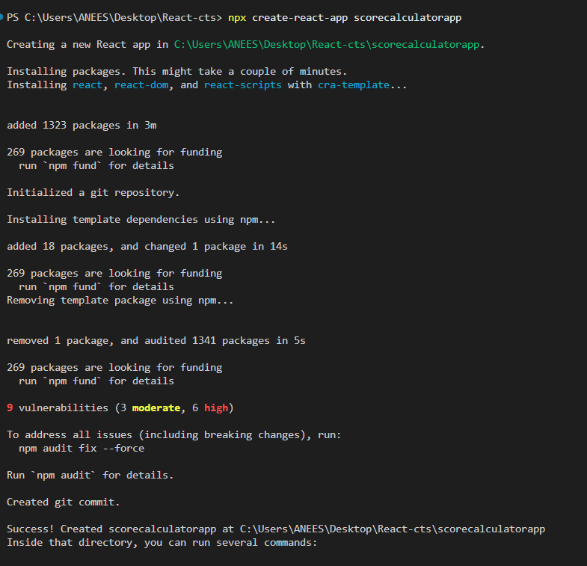

* Create a new folder under Src folder with the name “Components”. Add a new file named **“CalculateScore.js”**

import '../Stylesheets/mystyle.css';

const percentToDecimal = (decimal) => {

return (decimal.toFixed(2) + '%');

};

const calcScore = (total, goal) => {

return percentToDecimal(total / goal);

};

export const CalculateScore = ({ Name, School, total, goal }) => {

return (

<div className="formatstyle">

<h1><font color="Brown">Student Details:</font></h1>

<div className="Name">

<b><span> Name: </span></b>

<span>{Name}</span>

</div>

<div className="School">

<b>School: </b>

<span>{School}</span>

</div>

<div className="Total">

<b><span>Total: </span></b>

<span>{total}</span>

<span> Marks</span>

</div>

<div className="Score">

<b>Score: </b>

<span>

{calcScore(total, goal)}

</span>

</div>

</div>

); };

* Create a Folder named Stylesheets and add a file named “mystyle.css”

**mystyle.css**

.Name {

font-weight: 300;

color: blue;

}

.School {

color: crimson;

}

.Total {

color: darkmagenta;

}

.formatstyle {

text-align: center;

font-size: large;

}

.Score {

color: forestgreen;

}

* Edit the App.js to invoke the CalculateScore functional component

App.js

import { CalculateScore } from './Components/CalculateScore';

function App() {

return (

<div>

<CalculateScore

Name="Steve"

School="DAV Public School"

total={284}

goal={3}

/>

</div>

);}

export default App;

* Run the application

Run command: npm start

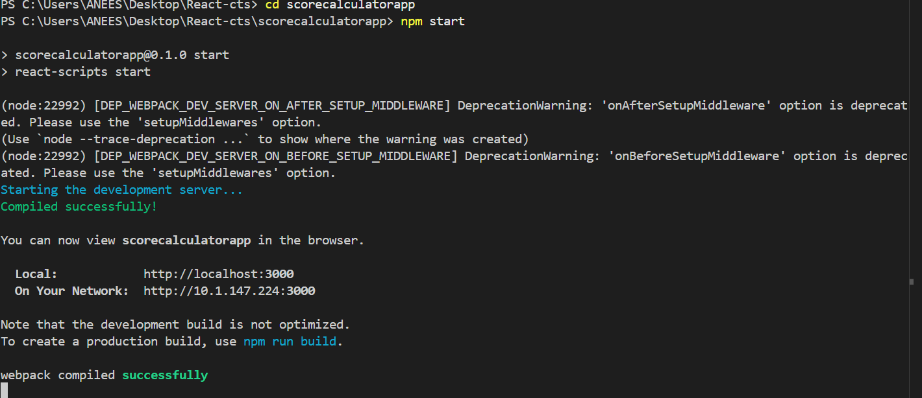

**Output:**

